TASK 9: Pipeline as Code and Server Deployment
Project: Dockerized Book Issue and Return System
Name: Swar Sawalkar
Roll No.: 23104B0023
Department: CMPN, Fourth Year
Division: C
Aim: To create a Jenkinsfile for the Book Issue and Return System with checkout, build, package, and deploy stages, and deploy the application using a server environment with at least one parameterized setting.
1. Introduction
Pipeline as Code is a DevOps practice in which the entire CI/CD pipeline is defined in a configuration file called Jenkinsfile. Instead of manually performing development and deployment activities, Jenkins automatically executes predefined stages whenever the pipeline is triggered.
In this task, a Jenkins pipeline is implemented for the Book Issue and Return System to automate source code checkout, application building, packaging, and deployment. The pipeline uses GitHub for source code management, Maven for building the application, and Docker with Docker Compose for deployment. An environment parameter is introduced to make deployment configuration flexible and reusable.
2. Objectives
- To implement Continuous Integration and Continuous Deployment using Jenkins.
- To create a declarative Jenkinsfile for automating the deployment process.
- To automate source code checkout from GitHub.
- To compile and build the Spring Boot application using Maven.
- To package the application into an executable JAR file.
- To deploy the application using Docker and Docker Compose.
- To parameterize environment settings for flexible deployment.
3. Tools and Technologies Used
Tool | Purpose
Jenkins | CI/CD pipeline automation
GitHub | Source code management
Git | Version control
Java 21 | Application development
Maven | Build and dependency management
Docker | Application containerization
Docker Compose | Container deployment
Spring Boot | Backend framework
4. Implementation
Step 1: Source Code Checkout
The Jenkins pipeline retrieves the latest source code from the GitHub repository using Git checkout.
Step 2: Build Stage
Maven is used to compile the application, resolve dependencies, and check for build errors.
Step 3: Package Stage
The application is packaged into an executable JAR file, which contains the required application components.
Step 4: Deployment Stage
The generated application is deployed using Docker Compose. Docker builds the application image and starts the required containers, including the application and MySQL database.
5. Jenkinsfile
The following declarative pipeline demonstrates the implementation:
pipeline {
agent any

parameters {
choice(
name: 'ENVIRONMENT',
choices: ['development', 'production'],
description: 'Select deployment environment'
)
}

stages {

stage('Checkout') {
steps {
git branch: 'main',
url: 'https://github.com/swar071005/Devops_Project.git'
}
}

stage('Build') {
steps {
bat 'mvn clean compile'
}
}

stage('Package') {
steps {
bat 'mvn clean package -DskipTests'
}
}

stage('Deploy') {
steps {
echo "Deploying to ${params.ENVIRONMENT}"

bat 'docker compose down'
bat 'docker compose up -d --build'
}
}
}

post {
success {
echo 'Build and deployment completed successfully!'
}

failure {
echo 'Pipeline execution failed!'
}
}
}
Note: This example assumes a Windows Jenkins agent, Maven installed and available in PATH, and a Docker Compose configuration in the repository root. The environment parameter is demonstrated in the pipeline; environment-specific deployment settings can be connected to separate Compose configurations.
6. Pipeline Workflow
GitHub Repository
Source code retrieval
Jenkins – Checkout
Fetch latest source code
Build – Maven
Compile and resolve dependencies
Package – JAR
Generate executable application
Deploy – Docker Compose
Build image and start containers
Running Library Application
Application and MySQL services
7. Parameterization
The pipeline uses an ENVIRONMENT parameter with two options:
- Development: Used for development and testing.
- Production: Used for production deployment.
This parameter allows users to select the target environment when starting a Jenkins build. It can be extended to load different configurations, database settings, and deployment environments.
8. Expected Output
After successful execution, Jenkins should display the following stages:
- Checkout – SUCCESS
- Build – SUCCESS
- Package – SUCCESS
- Deploy – SUCCESS
The application should be accessible through the configured deployment URL, provided all Docker services start successfully.
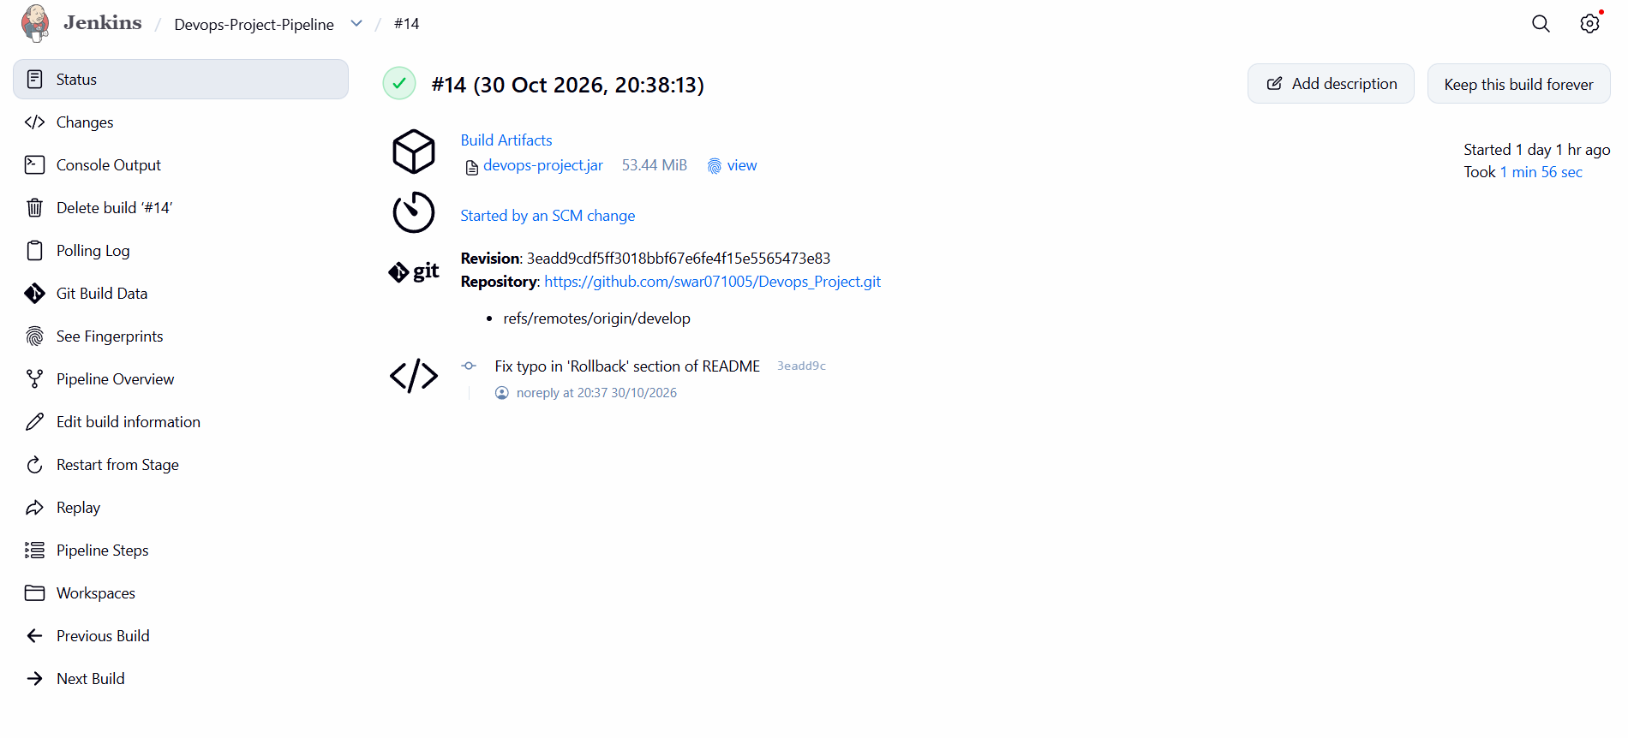
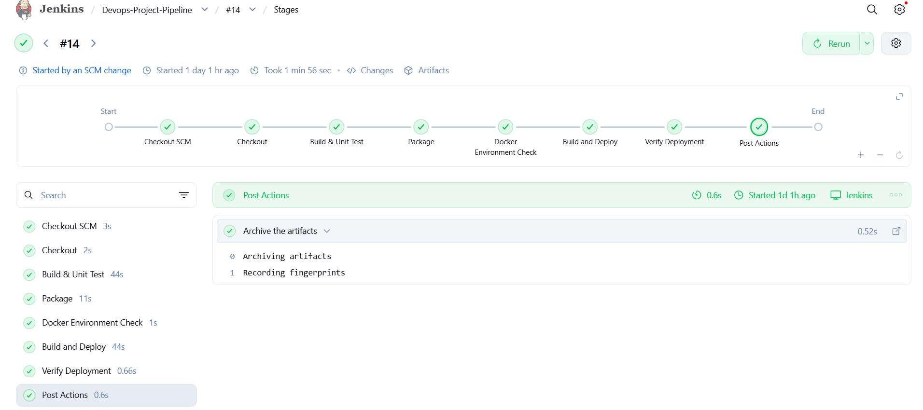

9. Result
The Jenkins pipeline was designed to automate the complete software delivery process of the Book Issue and Return System. The pipeline performs source code checkout from GitHub, builds the Spring Boot application using Maven, generates the executable JAR package, and deploys the application through Docker Compose. The use of a parameterized environment setting makes the pipeline more flexible and reusable. Thus, the task demonstrates the practical implementation of Pipeline as Code and automated application deployment using DevOps tools.

